Hired Equipment Tracking System HETS V1.0

User’s Manual V0.01

Table of Contents

Application Basics 3

Using this Manual 4

The Home Screen 5

Basic Navigation - Menus and Searching 7

User Preferences: Favourites 9

View/Edit Screens 11

Add "Things" 12

Printing and Reports 13

History 14

Managing Equipment Owners 15

Searching for Owners 16

Owners Details - Equipment 17

Owner Details - Contacts 19

Managing Equipment 20

Search for Equipment 21

Equipment Details - Top and Bottom 22

Equipment Details - Attachments and Seniority 23

Managing Projects 25

List Projects 26

Project Details - Header Information 27

Project Details - Hired Equipment / Requests 28

Hired Equipment Time Entry 30

Managing Requests and Hiring Equipment 31

Request List Screen 32

Creating a Rental Request 33

Rental Request Details - Top and Bottom 34

Rental Request - Request Status List 35

Rental Request - Processing an Offer to Hire 37

Managing Rental Agreement - Overview and Rates 38

Managing Rental Agreements - Attachments and Conditions 40

Managing Rental Agreements - Cloning an Existing Agreement 42

Managing Rental Agreements - Generating a Rental Agreement 43

Tips and Tricks 44

Changes from BC Bid 45

Rental Requests - Paper vs. Online 46

Last Verification Date 47

# Application Basics

Welcome to the MOTI Hired Equipment Tracking System (HETS)! This is the User’s Manual for government staff users of HETS - there is separate guidance for non-government users of the application. In this first section of the User’s Manual, we'll cover getting started with the application, the Home page and navigation basics. In this section we also cover how you can customize the application for your own use, and cover some things that you can't do - yet.

To log into the HETS application, start your browser and go to <https://prdsm.th.gov.bc.ca/hets/>. Note the "/" at the end of the address - it's required! If you have been asked to use the Test instance of the application, use the URL <https://tstsm.th.gov.bc.ca/hets/>.

If you have an account on the system and you are logged into your government workstation, you will be taken directly to the Home page of the application. If you are on a non-government workstation, you will be prompted for your IDIR and password before being given access. Please note that to access HETS, you must have BOTH an IDIR and an account on the HETS system. Other Government employees with IDIRs cannot access this application.

**NOTE: Coming from BC BID HETS?**

If you are coming to this system from BC Bid HETS, you will find that while you can accomplish the same things that you did on the old system, the methods are quite different on this system. You will not find the same menu items and screens in this system, and even some terminology has changed. Our goal in designing and building this system was to make it easier for users to accomplish the HETS program goals, and to do so online, with less paper. You can still use paper (of course!), but hopefully you will find it's just easier to do without duplicating the work of doing it on paper and then in the system. The last chapter of this User’s Manual has a list of some of the bigger updates to the system.

So - be aware that this is a different system - hopefully easier - than the old BC Bid HETS system, but since it is different it may take a bit to come up to speed on the changes.

### Using this Manual

If you are new to this version of HETS, we recommend you get started as follows:

* Review this first section, "Application Basics" to get a feel for the application.
* If you are familiar with the BC Bid version of HETS, review the last Chapter "Changes from BC Bid" to understand what's changed.
* Navigate through the sections of the app to see the different screens, referencing as needed the next four chapters (Owners, Equipment, Projects and Requests)
* Once you have a feel for the screens, look at the Tips and Tricks Chapter for guidance on getting your HETS work done.

As you go through this User’s Manual and the app, please provide feedback to the HETS Project Team on anything you find that isn’t quite right.

### The Home Screen

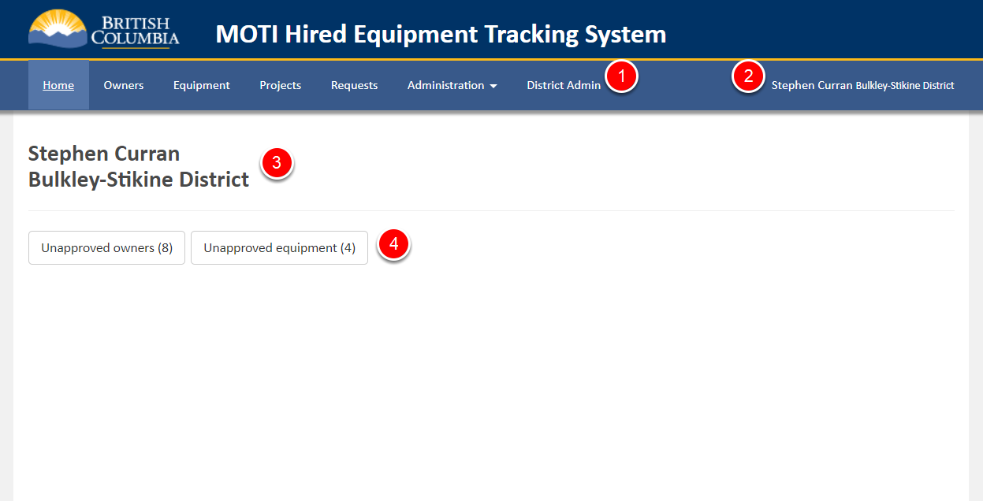

The screen pictured above is the Home screen that comes up on first starting the app, and on hitting the Home menu item.

The area (1) near the top of the screen is the system menu. Click on those items to navigate to the different parts of the application - Owners, Equipment, Projects and Requests.

NOTE: Only certain users will see the “Administration” and "District Admin" menu entries based on their role in the use of this app. Others will not see those options.

The area with the (2) at the top of the screen shows the current logged in user - e.g. you. If you don't see your name - please contact your System Administrator. The header area with the application name, system menu and logged in user appear on all of the pages in the app. The logged in user is also displayed on the Home page (3).

As you use the app you may see a blue "***Working...***" message over your name in the header from time to time. That is displayed when requests you make (e.g. searches) take a long time to complete. In normal usage, those messages will come up and disappear pretty quickly. Occasionally, if there is an error in the system a red "***Error...***" message will display in the same area. When that happens, you can click the message to see some additional technical details, and you should probably report the issue to the System Administrator.

In the main body of the Home page are some quick link buttons (4) about actions you may need to take as part of the HETS business process. Clicking those buttons will take you to the relevant list screen (eg. Owners) showing only the relevant items (e.g. Unapproved Owners). The quick links and other information on the Home screen may change over time as the users (you!) figure out the most useful things to have on the Home page.

### Basic Navigation - Menus and Searching

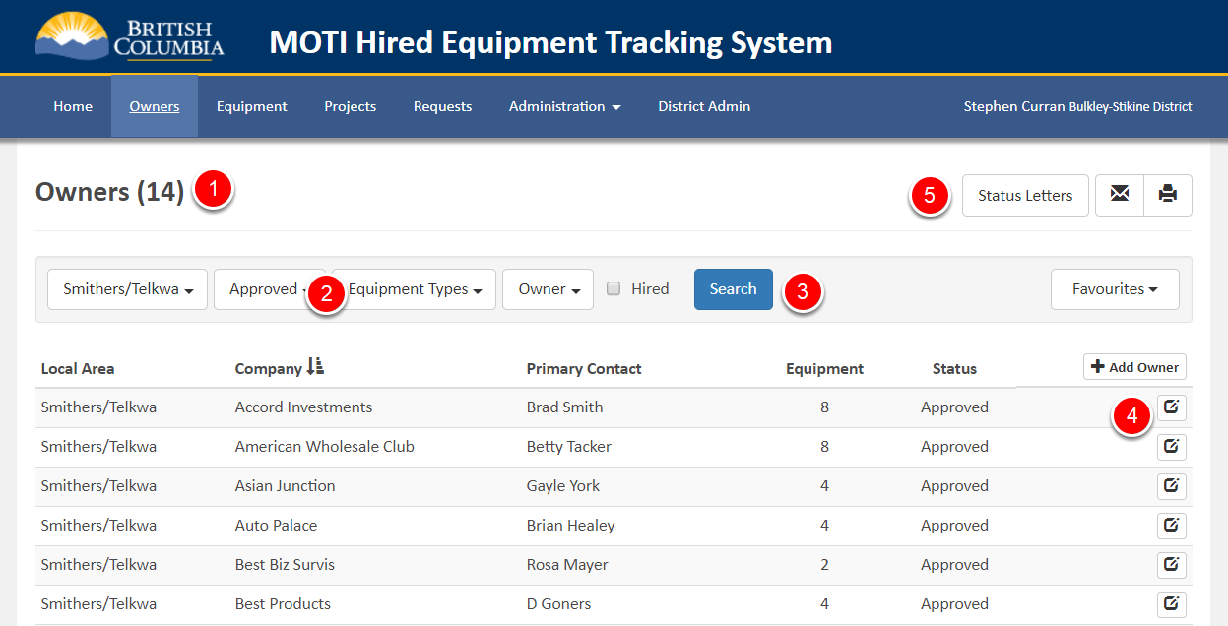

The screen above is like what you see when you first click the "Owners" link in the top menu - although the list of Owners may be longer. The following are some pointers about searching for information and navigating around the application. The numbers below correspond to the numbers on the image above.

1. On an application search screens (Owners, Equipment, Projects and Requests) is the title of the screen and a number in parenthesis - the count of things returned by the search. In the screen above, there are 14 Owners in the list (not all are in the screenshot) and the count is 14. So, if you want to get a count of something, you can set the search parameters (Step 3 - below) and the count will update when you Search.
2. The items in this section are the various search parameters you can use to find the exact set of things (Owners, in this case) you want to see in a list. Depending on what options you select, you can list a single Owner or every Owner in your District. Later in this manual we'll cover the exact search parameters available for the different list screens.
3. The "Search" button is what you click when you change the search parameters and are ready to search for the things meeting the new parameters. There will always be a default search executed when you first get to a search screen, but if you change the criteria and want to search again, you have to click the "Search" button.
4. At the end of each line in the search results (below the search criteria) is an icon that lets you drill down to see and edit the details of the item. In the image above, clicking that icon will allow you to see the details of the listed Owner.
5. Just above the search criteria are actions you can take that apply to the entire list. For example, click the "Printer" icon to get print out the displayed list of things. What you can do with the list will vary depending on what list screen you are on.

**WARNING**: Not all of the buttons on all of the screens are functional yet. If you mouse over a button and see a message - "This feature has not been released yet" - you will know the button does nothing at this time. Soon though!

Note that once you have executed a different search and left the page, the app will remember that search and run it again when you return to the page.

Some tips on setting the search parameters and ordering the list:

* If you select values from multiple drop downs, only things matching ALL of the criteria will be returned. For example on the Owners screen above, if you pick items from the Equipment Types dropdown and check the "Hired" box - only Owners that have the selected Equipment Types AND that have Equipment that is currently Hired in the program will be returned.
* Once you have selected some items for a drop down for searching (e.g. Equipment Types), you can remove that filter by clicking the "Select All" checkbox under the item twice. When you do that, no items will be selected, and no filtering will be done on that parameter.
* Click on the list Column names to order the list on that column. Click again to reverse the order on the column.

In the next section, we'll talk about Favourites - a mechanism you can use to create shortcuts to the searches you run most often - or that you want to appear first whenever you log into the app.

### User Preferences: Favourites

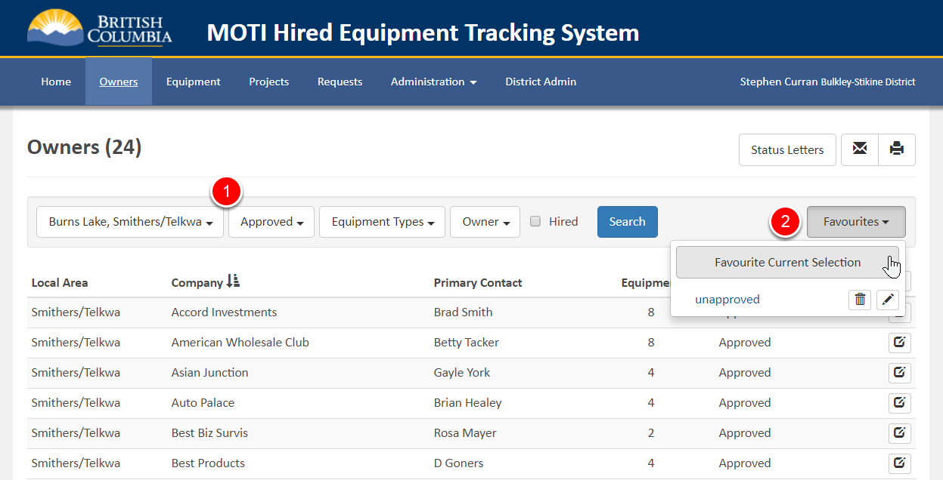

Favourites let you tune the application to your specific needs. Instead of having to set the parameters you are interested in and hitting the "Search" button each time you get to a search screen, you can create a Favourite of a particular search and jump straight to it. Here's how.

To create a Favourite:

1. Set the Search parameters to what you want for your Favourite. For example, to see only the approved Owners for two specific local areas, select the two districts from the Local Area dropdown, set the status to "Approved", and click the Search button.
2. Click the "Favourites" button and then, in the menu – click "Favourite Current Selections".
3. You will be prompted for a name of the Favourite - you can put in whatever you want, such as "Burns and Smithers". You can also set the search to be "Default" - see below on what that means.

To use a Favourite that you have created:

1. Click "Favourites" and you will see the name of the Favourite you created earlier.
2. Click on the name. The search parameters will be update and the search executed as if you had done the steps manually.

Notice that you can click the respective icons to edit and delete a Favourite after you create it.

If you set a Favourite to be the ***Default***, that favourite will be executed automatically when you first go to that list - you don't even have to select the Favourite to have it run. There can only ever be on Default on a page.

Note that Favourites are different on each Search page, meaning you have a different set of Favourites for Owners, Equipment, Projects and Requests.

### View/Edit Screens

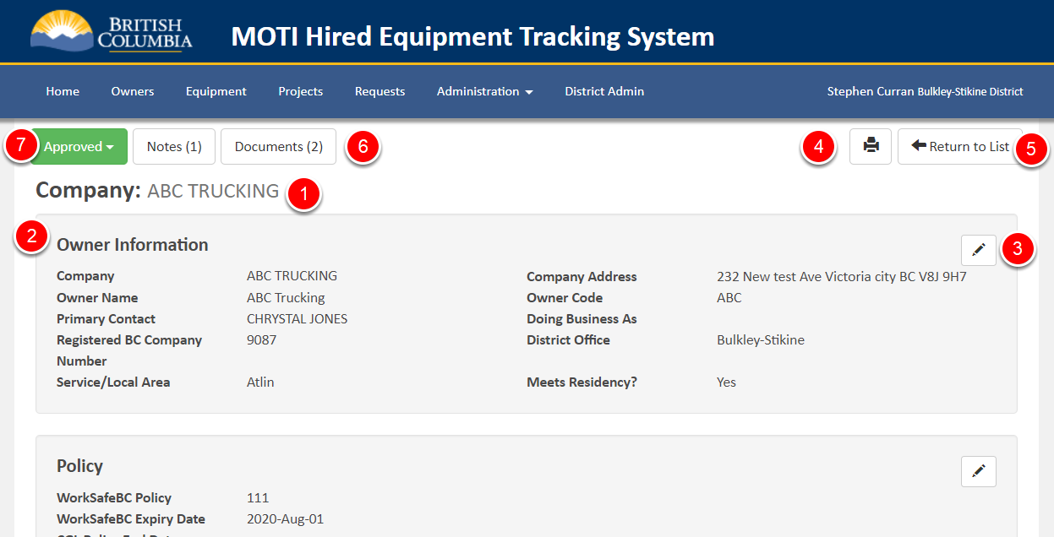

View/Edit screens are more varied in the system, but generally work in the same way. In the following, refer to the "Owner" screen above, but all of the screens work in similar ways. Here's an overview of the important numbered elements of a detail screen:

1. The "Thing" the details are about is listed at the top - in this case, an Owner, and the name of the Owner is displayed.
2. The details may be divided into sections - in this case "Owner Information" and below that "Policy".
3. Within a section, there may be a Pen icon that you can click to edit the details in that section.
4. Often at the top of the screen will be a Print button that opens up a print dialog with a nice presentation of the information for printing or saving as a PDF.
5. To return to the list screen associated with this item, click the Return to List button, top right.
6. Most Things allow you to associate Notes and attach documents to things like Owners, Equipment, etc. The numbers after "Notes" and "Documents" indicate how many of those items have been added. Click the links to see the list, view the items and to add additional ones.
7. There is always a Status associated with a Thing (such as with the Owner above), and a drop down/button shows you the status and allows you to change it. In general - the colour of the status matches the setting - green is “normal”, red is not.

Most entities in the system (e.g. Owners, Equipment) have an associated History listing at the bottom of the details screen. See the next section for more on "History" in the HETS app.

### Add "Things"

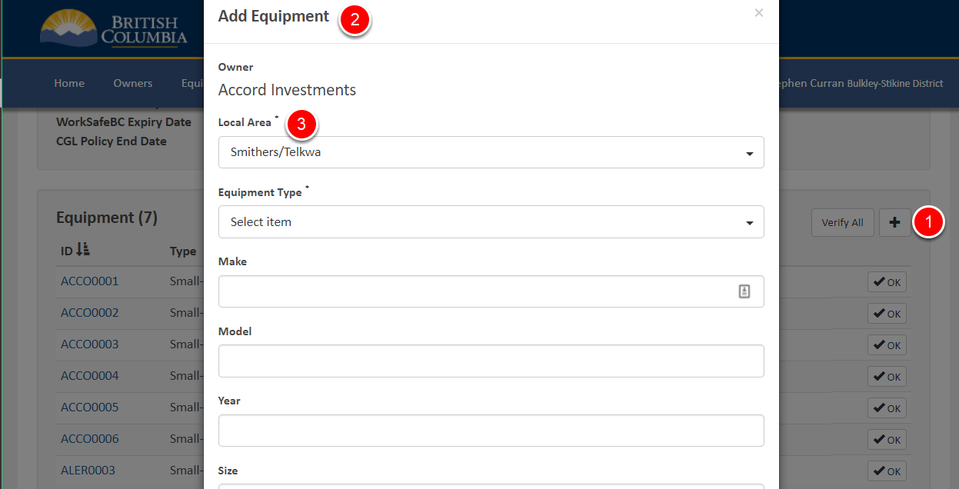

Throughout the app there "Add" actions to create new "Things" - Owners, Equipment, Projects, Contacts and Requests. The process is the same for each:

1. Click the relevant Add button (1) the screen.
2. A popup appears (2) over the current screen with an initial list of fields about the new "Thing". Some of those fields are required and have an * (3) beside the name, while others are optional.
3. A "Save" button is at the bottom of the screen that you can use to add the new "Thing", and a "Close" button to cancel the Add process.
4. Clicking the "Save" button usually takes you to the Details screen of the new "Thing". For the Add Equipment process on this screen, “Save” takes you to the Equipment Details screen.
5. Clicking the "Close" button returns you to the screen you were on, with the new "Thing" NOT added

The information entered in the screen can be updated on the Details screen of the newly added item.

### Printing and Reports

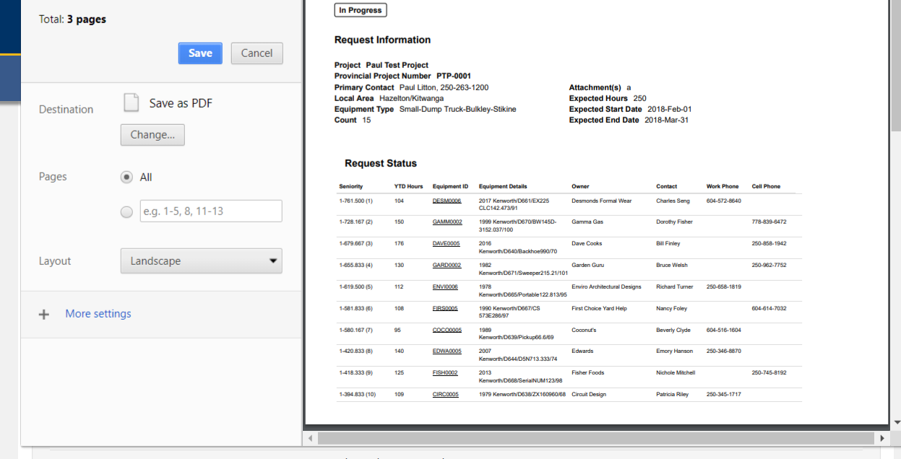

Throughout the app is the Print icon. When clicked, a screen such as the one above is displayed, giving you the chance to adjust the print out (e.g. portrait or landscape, pages to print and so on) and what printer to use. You should also be able to create a PDF. The precise details and features of the print capabilities depends on the browser you are using - Internet Explorer, Chrome or others.

When you click the Print button, the same contents that you currently have on the screen is printed in a nice format for paper. If you want, you could also use the Browser's Print button to print the screen contents, but the format will not be as nice as if you used the app's print button.

**Reports**

You can use the app's print buttons to get reports from the system that in the old BC Bid app were in a separate menu. For example, to get a report of the currently active Owners in a Local Area, go to the "Owners List" screen, apply those search parameters, click the Print icon and you'll get your report. This can be done from the List screens in the system - Owners, Equipment, Projects and Rental Requests. Printing is also available from the Details screens to get a nice printout for filing of, for example, a piece of Equipment.

Note that in addition to the Print button, there are a couple of PDF's generated from the system that can also be printed. PDFs are created when even more precise print formatting is needed. In HETS, PDFs are used for the actual Rental Agreements, and for the "Verify Equipment" documents that can be sent to Owners prior to Roll Over.

### History

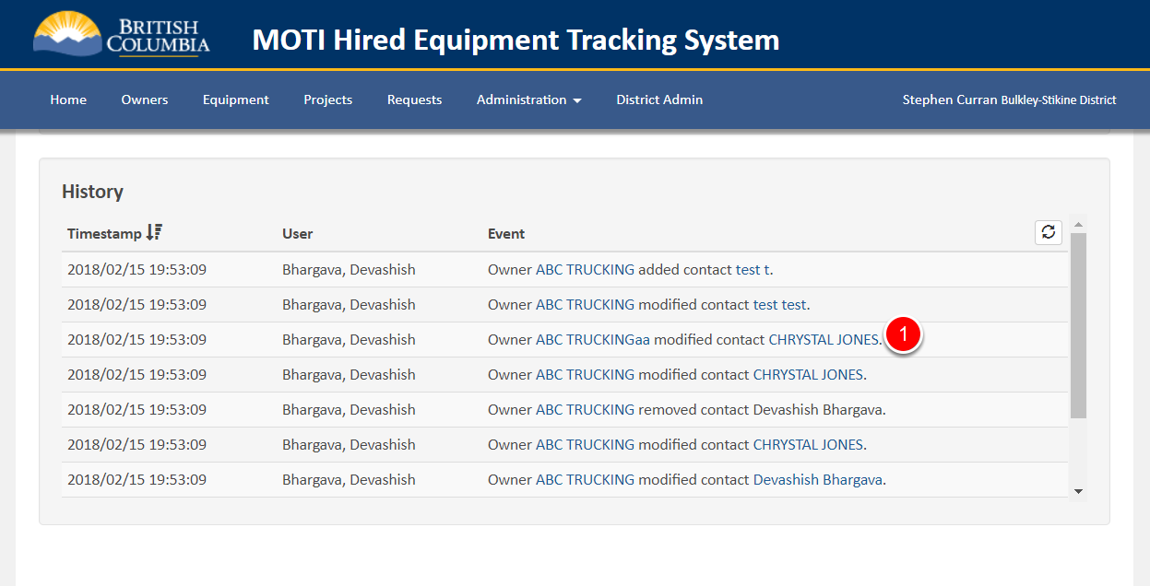

At the bottom of each of the details screen is a History section with a list of events that occurred related to the current item. The history lists the date/time of an event, the user that performed the event, and a brief logging message outlining the details of the event. The Event message often has links embedded in the message that lets you jump to the item. For example, clicking the link at (1) in the screen above would jump to the details about the contact that was modified in that event.

# Managing Equipment Owners

In this chapter we describe Owners section of the app - covering the Owners List and Owner Details screens. It is assumed that the reader has gone through "Application Basics" (the first chapter) of this User’s Manual.

### Searching for Owners

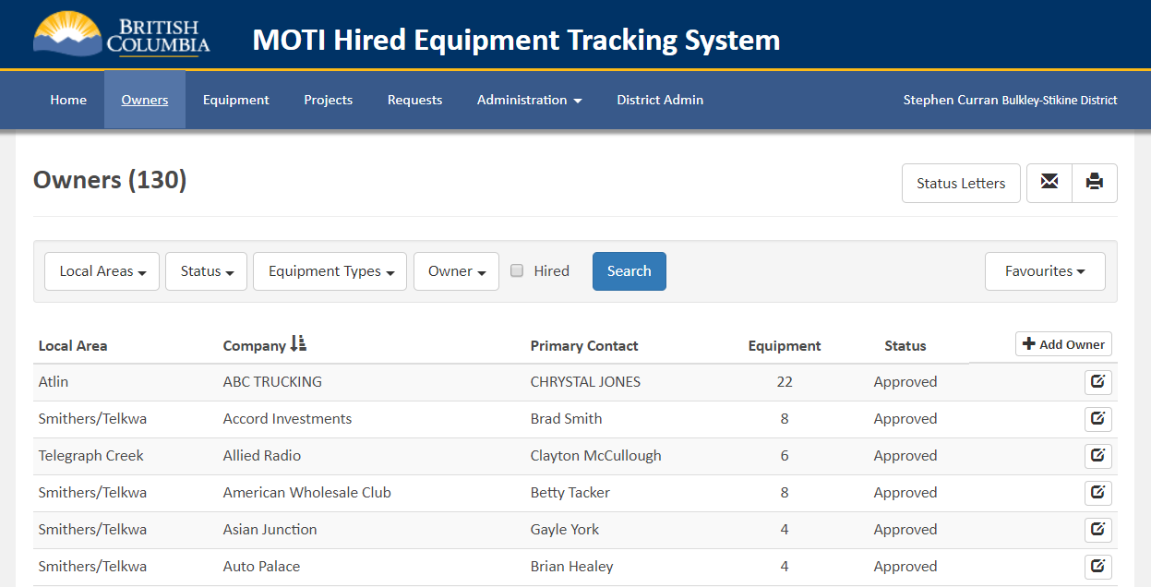

When you first go to the Owners screen (by clicking "Owners" in the top menu), the following search is executed:

* All Local Areas in your designated District. NOTE: If the wrong District comes up, contact your System Admin to correct the District on your account.
* The Status (2) is "Approved" - only Owners that have been approved are included.

The "Hired" checkbox will include in the list the Owners that have Equipment that is currently hired through the HETS Program.

To add an Owner record to the system, click the "Add Owner" button (1). To View/Edit the details about an Owner, click it's Edit icon (2).

Once you have the list of Owners on the screen, you can click the "Status Letters" button to get a PDF document suitable for mailing out to the listed owners to get confirmation on the status of their Equipment based on the information currently in the system. We'll cover that process later in this manual. If you hit the button with a large list, be patient - it might take a while to get your PDF for printing.

Click the Edit icon (2) for one of the Owners to follow along on the next screen.

### Owners Details - Equipment

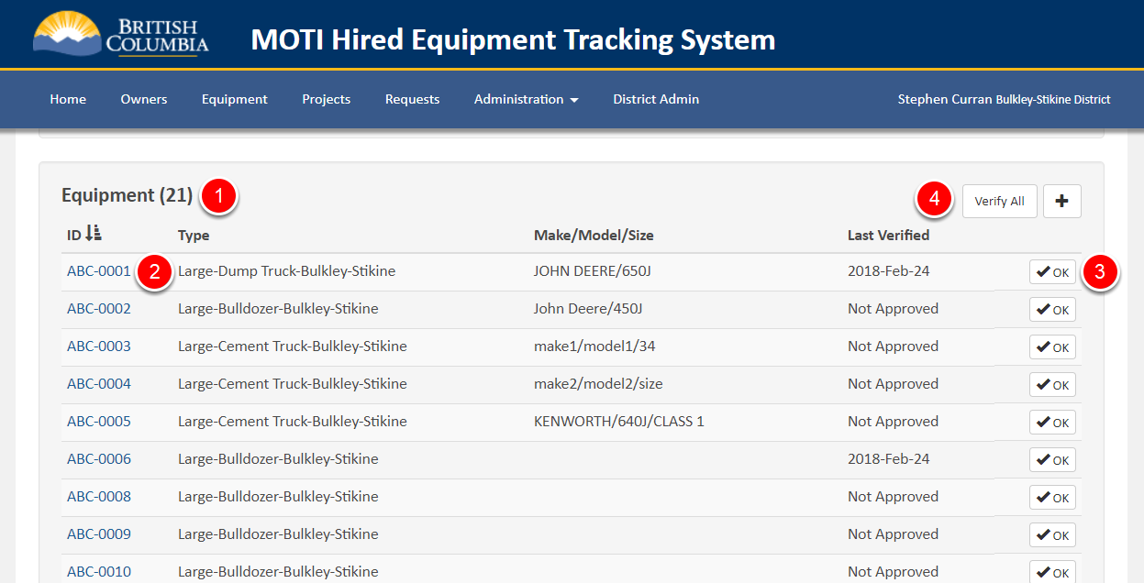

The Owner Details screen has most of the standard features of a Details screen, as described in the first chapter of this manual. Notably:

1. A Status setting for the Owner to adjust the status across Unapproved, Approved and Archived.
2. Notes and Documents at the top of the screen, and a History table of events related to the Owner at the bottom.
3. Two editable sections, one about the Owner (e.g. Company Name, Owner Name, Address, etc.) and one about Insurance Policies - WorkSafe BC and CGL.

There are two other list sections on the screen - Equipment (see screenshot above - from part way down the Owner details screen) and Contacts (covered in the next section of this Manual).

In the Equipment section, you can see a list of the equipment associated with the Owner with a count at the top of the list (1). Within the list, you can open the Equipment Details screen by clicking the Equipment ID (2). The list includes some other summary information about the Equipment - Type, Make/Model/Size and the date the Equipment was last verified. See the section "Equipment Last Verified Date" about the background of "Verified Date" feature (last Chapter of this manual). To update the verification Date of a piece of approved Equipment, you can either click the "OK" button (3) on a single piece of Equipment, or click "Verify All" at the top of the screen (4). You might use Verify All when you are talking with an Owner and updating all of their Equipment at once.

Finally, to add a new piece of Equipment, click the "+" icon (5). On click, a popup of basic information about the Equipment will appear with some fields required. On submission of that data, you will be taken to the Details screen for the Equipment (see the next Chapter about Equipment). On creation of the piece of Equipment, the ID of the Equipment will be automatically created - a combination of the Owner prefix and a number unique to that Owner.

### Owner Details - Contacts

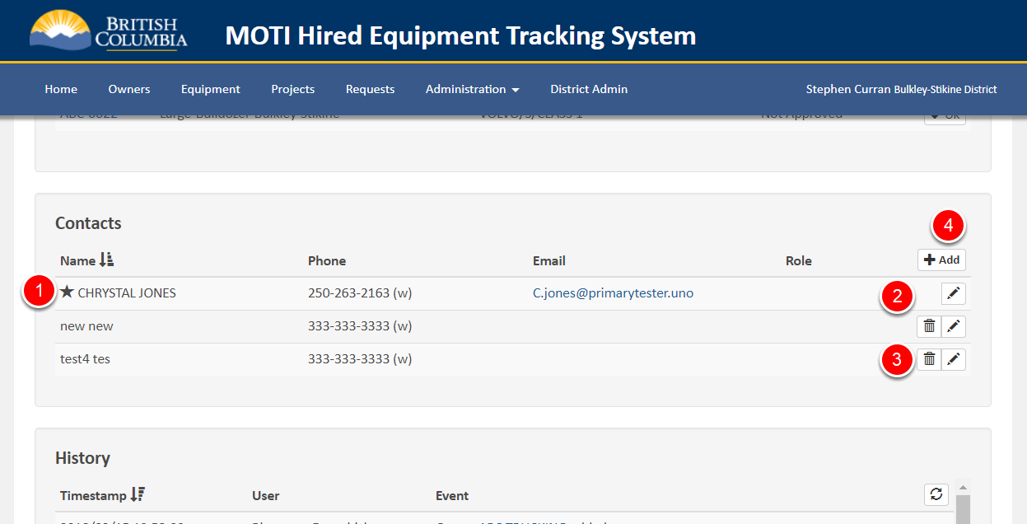

Below the Equipment List section on the Owner Details screen is the list of Contacts for the Owner. Any of the individuals you interact with related to an Equipment Owner can be added to the Contact list.

One of the Contacts (the one with the cool star) (1) is the ***Primary Contact***. Each Owner must have a least a Primary Contact - hence you can't delete the Primary Contact (2). To make a different Contact the Primary Contact - edit that Contact and click the "Make Primary" on the edit popup. The Primary Contact's name is listed at the top of the Owner Details screen and on the Owner List screen.

For non-Primary Contacts, click the trash can icon (3) to delete the Contact. Use the Edit/Pen icon to edit the details of any Contact.

Click the "Add" (4) button to add a new Contact for the current Owner.

And that's it for Managing Owners. Up next - Equipment.

# Managing Equipment

In this Chapter of the User’s Manual we cover managing Equipment. We've covered how to add a piece of Equipment already - from the Owner Detail screen - but how is Equipment managed after it has been added to the system? It's all covered here.

### Search for Equipment

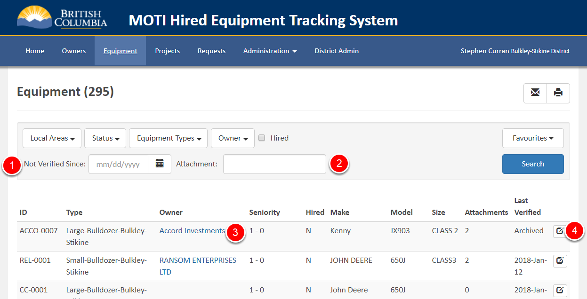

Searching for Equipment is much like searching for other things in the app - search parameters, a search button and the ability to save Favourites. If you don't know about searching - see Chapter 1 - "Application Basics".

Most of the search parameters are obvious by now, but a couple deserve attention:

* The "Not Verified Since" (1) will list only Equipment that has not been verified since a given date. Use this to catch up on checking with Owners if pieces of Equipment are still in use.
* The Attachment text box (2) allows searching on the name of an Attachment. The searching is NOT case sensitive (e.g. use upper or lower case) and any attachments containing the string will be found. For example "Va" (or "va") will find any Equipment with an attachment that has "va" in their name - e.g "Jet/Vac System", "Jet/Vac", "Vaccuum", "Salvage", etc.

Within the search results are a couple of useful links:

* The Owner column (3) contains a link to the Owner Details screen.
* The end of line View/Edit Icon (4) goes to the Equipment Details screen.

Note that there is no "Add Equipment" button on this screen. Recall that button is on the "Owner Details" screen, so that the Equipment can be linked to the Owner as it is created.

Nothing too tricky here, so let's move on to the Equipment Details screen.

### Equipment Details - Top and Bottom

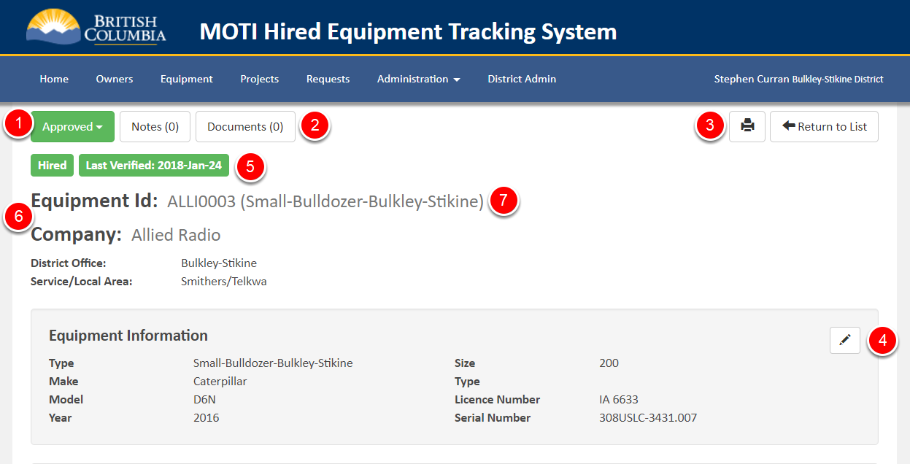

The top and bottom sections of the Equipment Details screens has some things we've seen on the Owner Details - at the top the status (1) of the Equipment (Unapproved, Approved, Archived), Notes and Documents (2), Print and Return to List (3) and at the bottom - the History table (not shown) about the Equipment. As well near the top is a section of Equipment Information that can be edited by clicking the Pen icon (4) in the top right.

Some extra buttons (5) are below the Status indicator - the Hired indicator (Green if the Equipment is currently being rented in the HETS program) and the last verified date (Green if it is within the last year).

Between the buttons at the top and the Equipment Information is some information (6) that cannot be edited - the Equipment ID, Equipment Type (7), Company, District and Local Area. In the future, that information might become editable in limited circumstances – e.g. by admin users. The reason for taking such care with that data is that a change to it will trigger updates/changes to other elements of the system. For example, a change of Equipment Type will trigger updates to the Seniority Lists of the current and future Equipment Type - not something that should be done lightly!

### Equipment Details - Attachments and Seniority

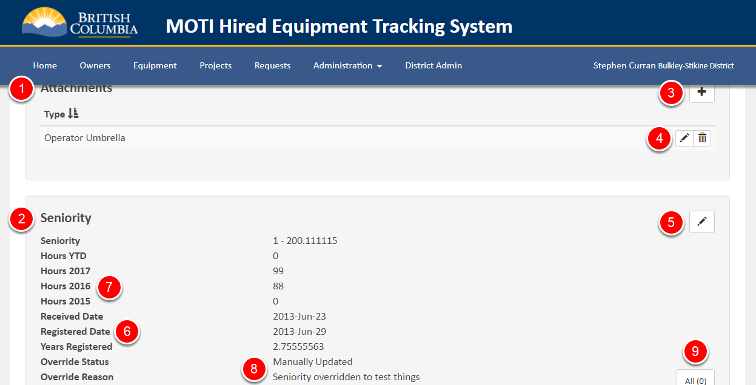

Below the Equipment Information section are two other important sections - Attachments (1) and Seniority (2).

Attachments are pretty easy to deal with. Use the "+" button (3) to add an attachment. Once an attachment has been added, you can use the Pen and Trash Can (4) icons to edit and delete the attachment, respectively.

Seniority is easy to update by the User, but should be done with great care as an update is a little trickier behind the scenes, and could have a big impact on the Hiring Process. The Pen (5) icon allows the User to edit the four fields from which the Seniority number is derived - the Registered Date (6) and Hours from each of the previous three years (7). When entering the updated information, the user must record the reason for the update so that it is available for auditing purposes. On saving the information, the following occurs:

* All of the current Seniority fields are stored in an audit table so a full history is retained.
* The Seniority fields are updated to what was entered by the User, and the Seniority score is recalculated.
* The Seniority List for the Equipment Type is recalculated, including possible updates to the next Rotation List (if necessary).
* The fact that the Seniority Information was manually updated is recorded (8)

Even a small change in the Seniority information may trigger significant changes in the Seniority List.

**NOTE**: Any Request already started will NOT be affected by a Seniority List update. If the User wants to impact an active Hiring Process with a Seniority Update, the Request will have to be cancelled, the Seniority Update made and a new Request created. We'll get into Requests and Rotation Lists later in the User’s Manual.

Finally, to see the Seniority History of the Equipment - including both Roll Over updates and any manual updates, click the "All" button in the bottom right (9). A table is displayed listing all of the Seniority Updates over the life of this piece of Equipment.

That's it for Managing Equipment. On to Projects!

# Managing Projects

If you have gone through the previous sections of the app - Projects will be pretty simple. That's good because Requests will be a little trickier - that's where the fun happens in HETS! However, for Time Entry, Projects are key. From the Projects Detail screen, a User can see the full list of currently hired equipment for a Project and enter time for each piece. This makes it really easy to receive the time slips from a Project and quickly enter them against the Rental Equipment.

### List Projects

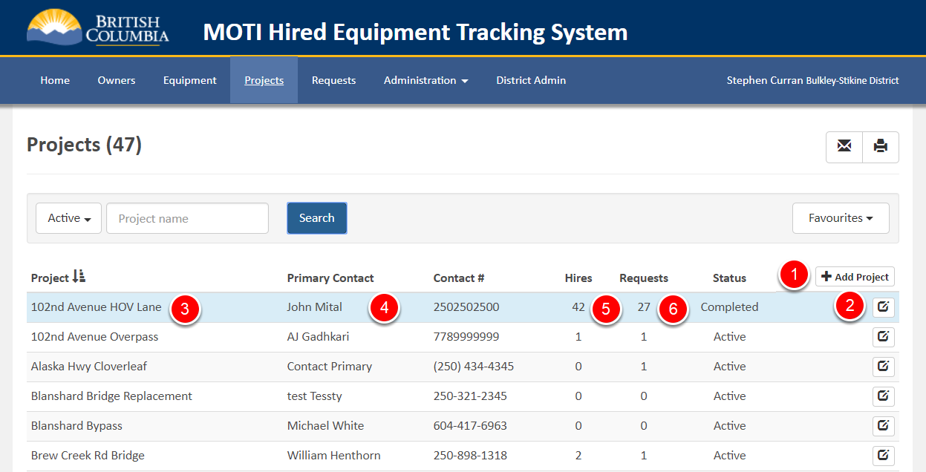

The Project List screen operates the same as all the List screens - just with fewer search parameters. The Project Name search parameter (1) works like the Equipment Attachment search we saw earlier - upper/lower case does not matter, and any Project Names containing the entered value will be listed.

Use the "Add Project" (1) button to add new Projects, and on the right side of each Project line is a View/Edit button (2) to open the Project Details screen.

Within the Projects List is HETS information about the Project, including the name (3), Primary Contact (4) information, and counts of Equipment Hires (5) and currently active Requests (6) on the project.

### Project Details - Header Information

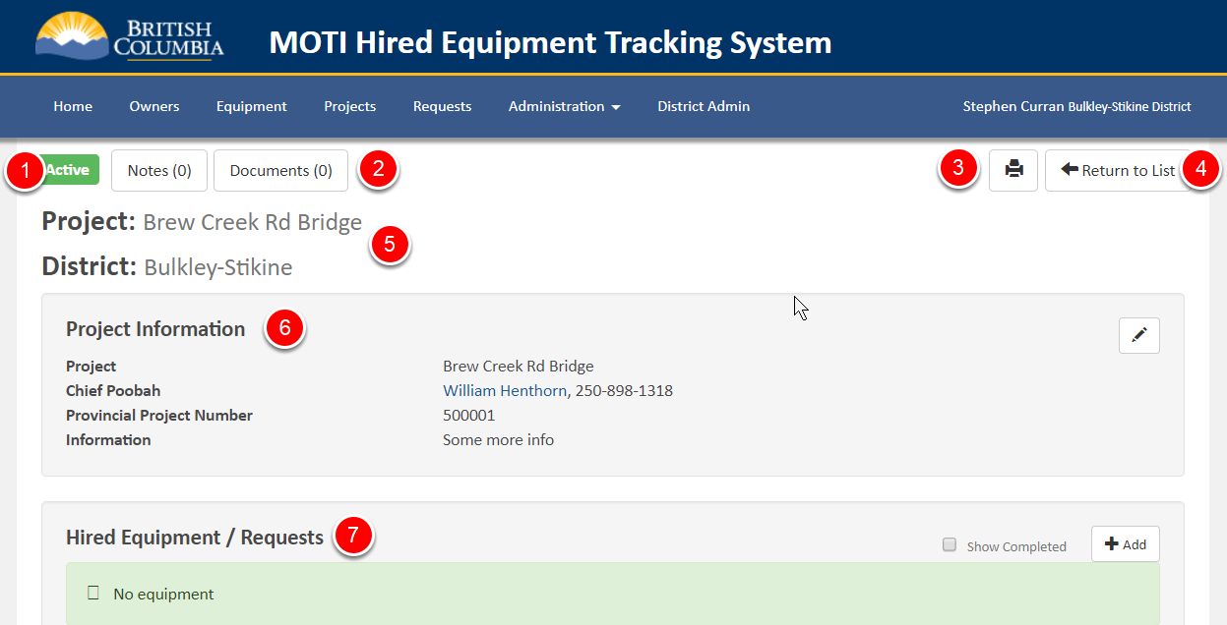

The Details screen for a Project has a header section much like the ones we have seen earlier in this User’s Manual. At the top is a Project Status (1) button (Active or Complete), buttons to add/view Notes and Documents (2), a print button (3) and a button to Return to the Projects List (4). Below that is the Project Name and District (5), and some Project Information that can be edited (6).

Not shown, but at the bottom of the screen is a Contacts table and a History table. The Contacts table works just like the Owners Contacts covered earlier, including the ability to add, update and remove contacts and set a Primary Contact for the Project. The History table is for viewing the updates that have been made to the Project, by whom, and when.

The interesting part of the Project Details screen is the table below the Project Information - the lists of Hired Equipment and active Requests (7). That's covered in the next section.

### Project Details - Hired Equipment / Requests

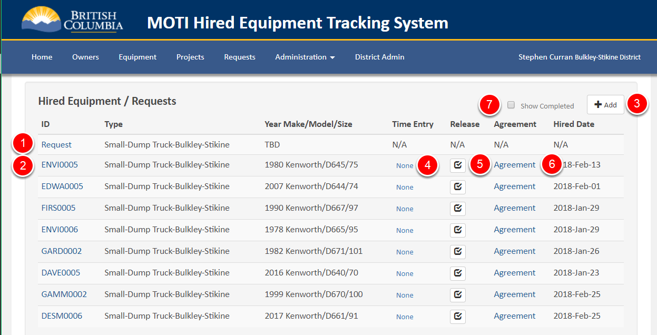

The Hired Equipment / Requests table on the Project Details screen provides the status of all currently active Requests (1) for this Project, and lists all of the active and (optionally completed) Hires (2) against this Project. From this table you can take all the HETS-related actions for this Project, including:

* Creating requests (3)
* Processing Requests (1)
* Going to the Equipment Details screen for a Hired piece of Equipment (2)
* Adding Time Entries for Hired Equipment (4)
* Releasing (Ending a Hire period for) a piece of Equipment (5).
* Viewing/Editing/Printing the Rental Agreement for a piece of Equipment (6)

By default only the currently Hired Equipment is listed in the table. By clicking the "Show Completed" checkbox (7) the both hired and released equipment is listed. Printing that is a great way to report on all of the Hires for a project.

Note that after Releasing a piece of equipment (ending the hire), you can still add Time Entries for that hire. Releasing the piece of equipment means that when you are processing another Rotation List for that Equipment Type, that piece of equipment will no longer be shown as "Hired", allowing it to be Hired without doing a "Force Hire".

We'll cover the hiring process, including Rental Agreements, in the "Managing Requests" chapter of the User’s Manual. In the meantime, we'll assume that a piece of equipment has already been hired and have a quick look at the Time Entry screen.

### Hired Equipment Time Entry

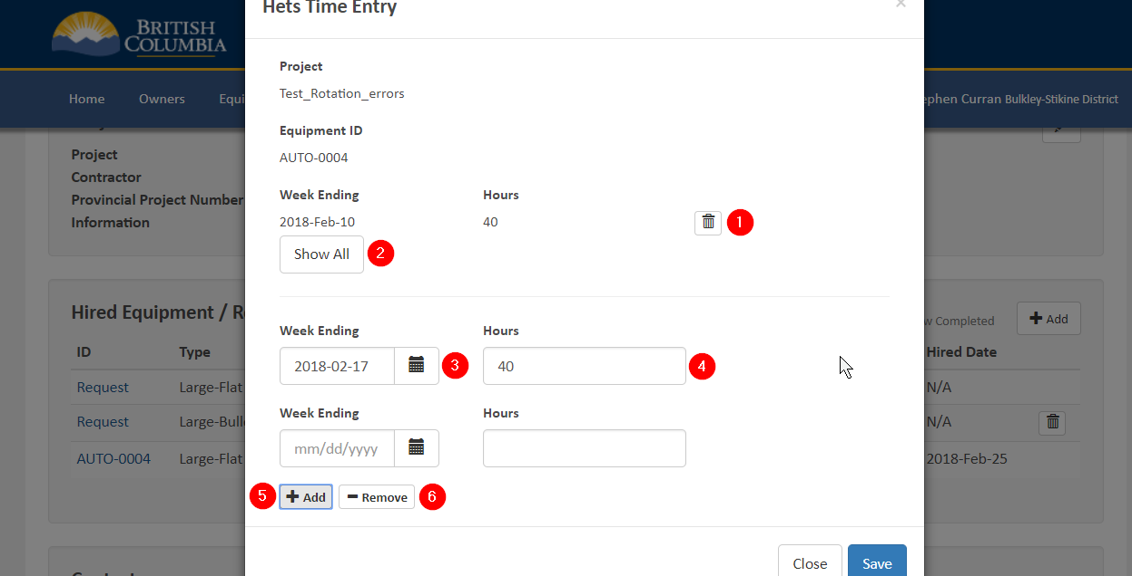

The Time Entry screen can be accessed from several places in the system when you can see a piece of Equipment that has been hired. Most commonly a HETS User will do that from the Project screen when processing the paper Time Slips for all of the Equipment hired for a Project. On clicking one of the Time Entry links, the screen above comes up.

Time is entered on a weekly basis. The most recent Time Entry is displayed on popup (1), including the ability to delete each entry. To see all previously entered time records, click the “Show All” button (2).

To add more time, select/enter the Week Ending (3) – must be a Saturday – and the Hours (4). Click the Add button (5) to add another entry and repeat the data entry process. Click the Remove button (6) to delete the most recent entry. Click the Save button to save the newly added time records.

# Managing Requests and Hiring Equipment

The Rental Request ("Requests") pages are where the Hiring Process takes place in HETS. A "Rental Request" in this system is:

* A request to hire some number of pieces of equipment
* All of the same Equipment Type
* In a single Local Area
* For a single Project

The pages for Rental Requests are the same as we have seen before - a searchable Rental Requests list screen and a Details screen for a single Rental Request - including the management of the Rotation List for the hiring process. Once a Hire decision is made for a piece of equipment, there is the ability to enter information about, generate and print a Rental Agreement. There are some shortcuts that allow for the quick generation of similar Rental Agreements.

The following walks through the pages that make up this section of the app.

### Request List Screen

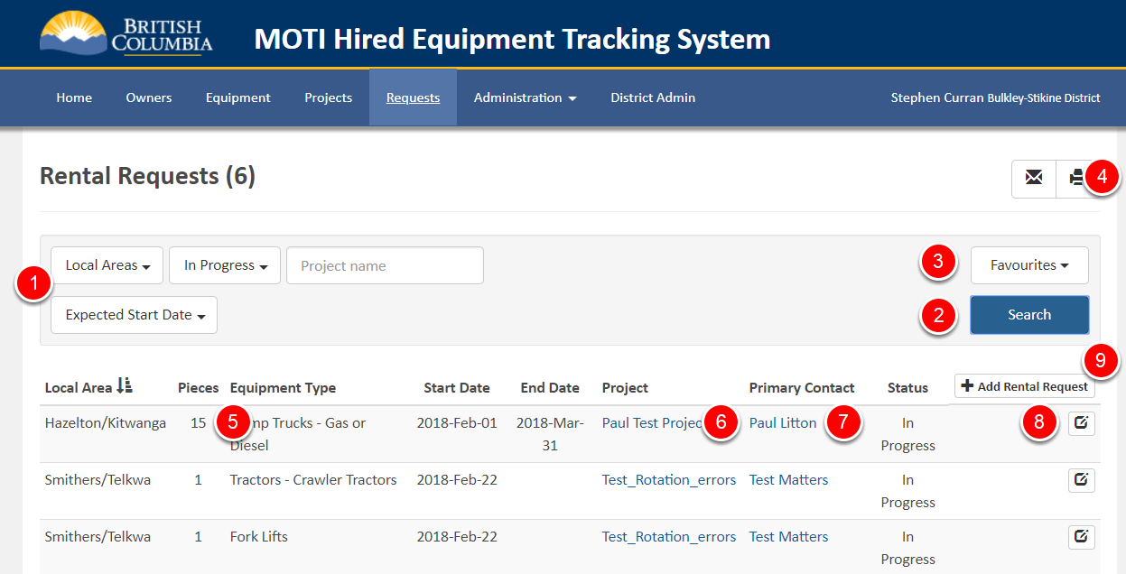

The top of the Rental Request List screen has the same features as list screens we’ve seen before - search parameters (1), a search button (2), Favourites (3) and a print button (4).

Within the list is basic information about the search results, including the Local Area, number of pieces and type of equipment to be hired (5), the start/end date of the rental period, the Project (6), the Primary Contact (7), the Status of the Rental Request and a View/Edit icon (8) to go to the Rental Request Details.

The Project and Primary Contact information are links. When clicked, the Project link (6) goes to the Project Details screen, while the Primary Contact link (7) (should) open an email to the Primary Contact in Outlook (it's a "mailto" link for those with a technical background).

At the top of the results table is an "Add Rental Request" link (8) to create a new Rental Request, which we will talk about next.

### Creating a Rental Request

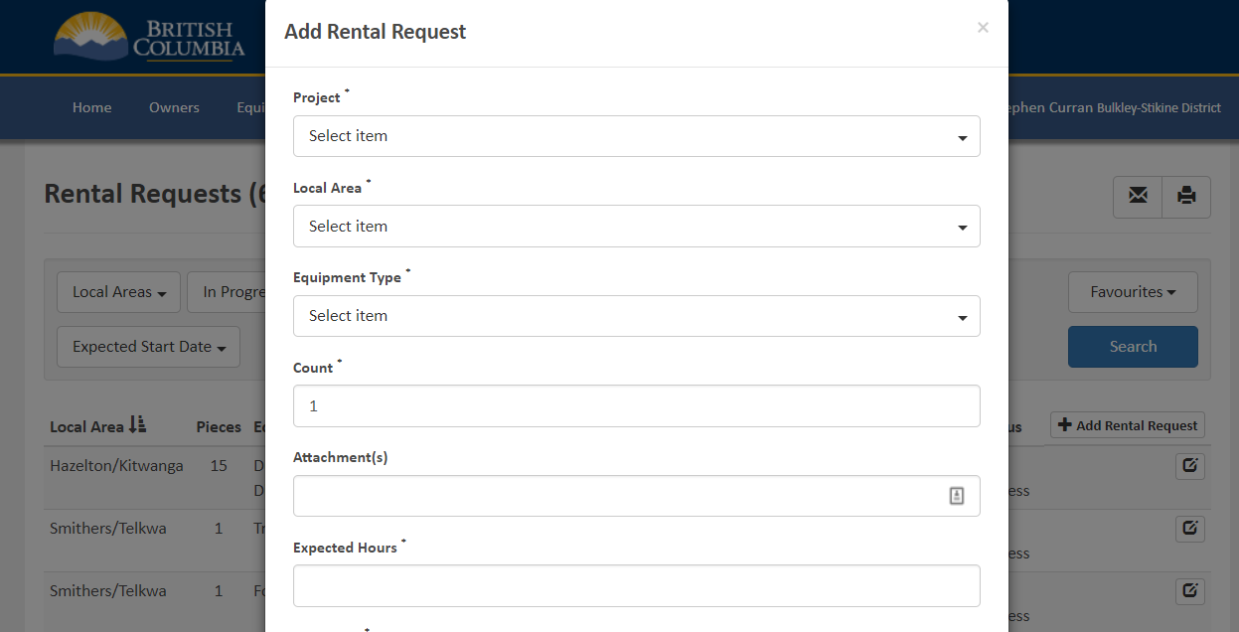

The Add Rental Request popup is similar to other add popups we've already seen - a form with some required and optional fields and a Save button at the bottom to create the Rental Request, and a Close button to cancel the creation process. Some notes on the fields to be completed:

* "Count" is the number of pieces of Equipment to be hired
* Attachments is just a text field for entering any Equipment Attachment requirements for the Rental.
* Expected Hours is needed to allow the app to show when a piece of equipment would go over its annual limit if selected.
* Not shown is the required "Start Date" for the Rental. End Date can also be filled in, but it is optional.

The action at the completion of the process is the creation of a Rotation List for the given Equipment Type and Local Area. Note that if a Rotation List already exists for the given Equipment Type/Local Area, an error is displayed, and the Rental Request will not be created. There can only be 1 Rotation List active at a time for a combination of Equipment Type and Local Area.

If the Rental Request is created, it will have a Rotation List. The list will have been created in the order that the Owners of the Equipment should be asked if they want the work according to the HETS rules. That is:

* Block order - 1, 2 (if Dump Truck) and Open.
* Request Order within each block - e.g. starting from the one AFTER the last Owner asked, per block.
* Including information about Equipment that is near or over their annual limit.

### Rental Request Details - Top and Bottom

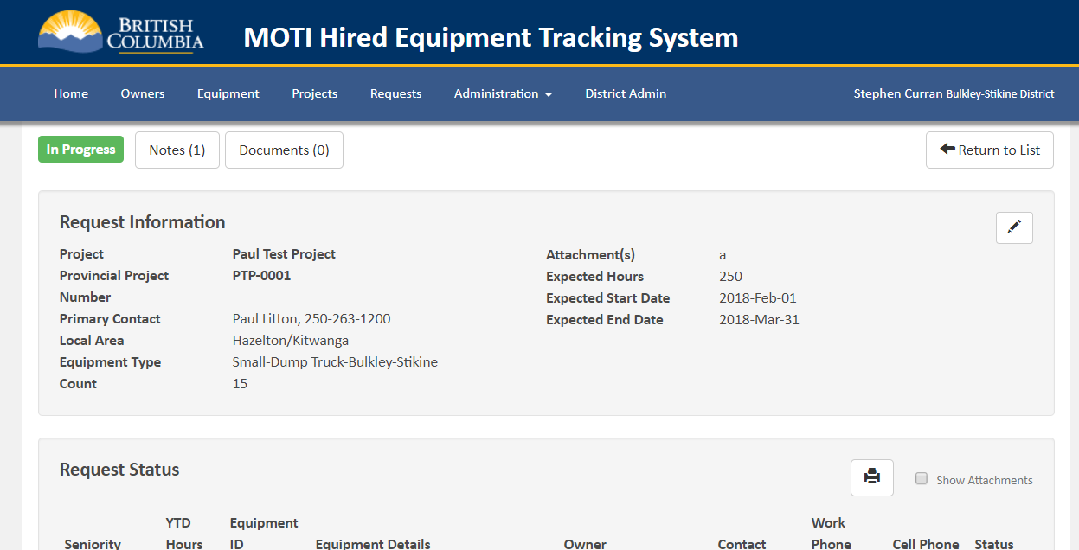

The top of the Rental Request details screen is similar to the other Details screens we've seen before - status, notes, documents, return to list and a section of editable information about the Rental Request. At the bottom of the screen (not shown) is the History table - events that have occurred related to the Rental Request - when and by whom.

The action for a Rental Request is the Rotation List that is in the Request Status. Let's look at that.

### Rental Request - Request Status List

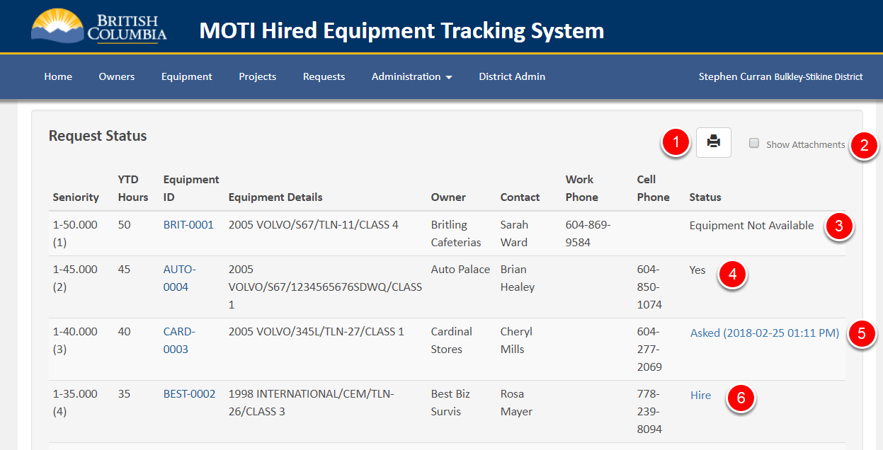

As mentioned in the section above on creating a Rental Request, associated with each Rental Request is a Rotation List. The Rotation List is created at the time the Rental Request is created based on the current state of the Equipment Type Seniority List for the selected Local Area. The list is ordered based on the HETS hiring rules, top to button based on the order that the Owners should be contacted about renting their piece of equipment. That is, within each block the next Owner's Equipment to be asked is first, followed in order by the rest of the Owners of Equipment within that block, and the blocks ordered from 1 to Open.

At the top of the list is the ability to print the list (1) and to show the Equpment Attachments for each piece of Equipment (2) - if that is important for the hiring process.

With the list ordered based on the HETS Rules, a Rental Request is processed as follows:

1. Start with the first Owner's piece of Equipment.
2. Contact that Owner and see if they want to rent their piece of Equipment. Click the "Hire" link to record their response (next screenshot).
3. If Yes - the Rental Agreement screen for that piece of Equipment will be displayed.
4. If No - select the reason.
5. If there is no immediate response from the Owner and you want to wait for a response - mark the response as "Asked".
6. If there are enough "Yes" responses to satisfy the Rental Request - stop the process - **Done!**
7. If there are enough "Yes" and "Asked" responses - pause the process - but you will have to come back to continue with the "Asked" responses.
8. Otherwise, move to the next Owner's piece of Equipment on the list and continue at Step 2 (above).

Each time a piece of equipment is updated with a Yes, No or Asked, the Seniority List's "Next to Ask" piece of equipment is updated. This ensures that the next time a Rotation List is generated, the list is in the right order according to the HETS Seniority Rules.

In the screenshot above, the Rotation List processing is partially completed.

* An Owner said "No" (3),
* A second Owner said "Yes" (4),
* A third Owner has been Asked, but hasn't responded yet (5), and
* The "Hire" link (6) is available for the rest of the Equipment on the list.

Clicking the "Asked" (6) or "Hired" (5) link on a piece of Equipment opens a popup - covered in the next section.

Note that at any time, the HETS User can click the “Hire” link for a piece of Equipment and choose to “Force Hire” that piece of Equipment. Doing so does ***NOT*** update the “Last Asked” status of the piece of Equipment on the Seniority List. So, if that is the only piece of Equipment hired and the list is marked completed, the next Rotation List will be the same as the current one.

### Rental Request - Processing an Offer to Hire

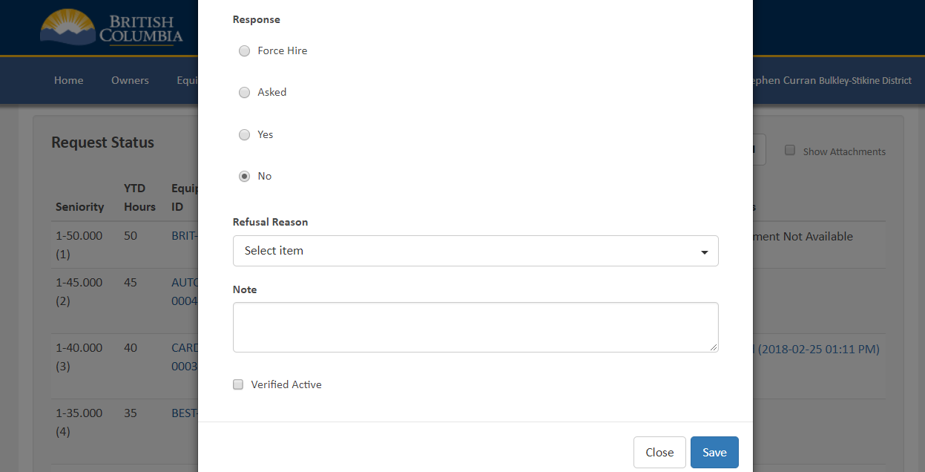

When the "Hire" link is clicked for a piece of equipment the popup above is presented and you can choose one of the options. Different behaviours occur based on what you choose:

* **Force Hire**: On Save, you will be required to enter a reason for the Force Hire, and that will be recorded in the HETS audit log.
* **Asked**: The date/time of the saving of the status is recorded and displayed on the Rotation List.
* **Yes**: Marks the Equipment as "Yes" indicating the piece of Equipment will be hired.
* **No**: A refusal reason is displayed (visible in the screenshot above) and a selection must be made.

The "Note" field is optional, but can record anything relevant about the request/response activity with the Owner.

The "Verified Active" checkbox is automatically set if the "Yes" or "Force Hire" is selected, and can be manually set (or unset). On save, if the checkbox is set the "Last Verified Date" for the piece of Equipment is updated to today. This means that the piece of Equipment will not need to reverified immediately before Roll Over (unless you want to do it then). See the last Chapter of this User’s Manual for more on the "Last Verified Date" for Equipment.

On clicking "Save", if the selection is "Yes" or "Force Hire", indicating the piece of Equipment will be hired, the status of the Equipment is changed to "Hired" and the next screen to appear will be the Rental Agreement screen to complete the Hiring process. That's the next screen we'll cover.

### Managing Rental Agreement - Overview and Rates

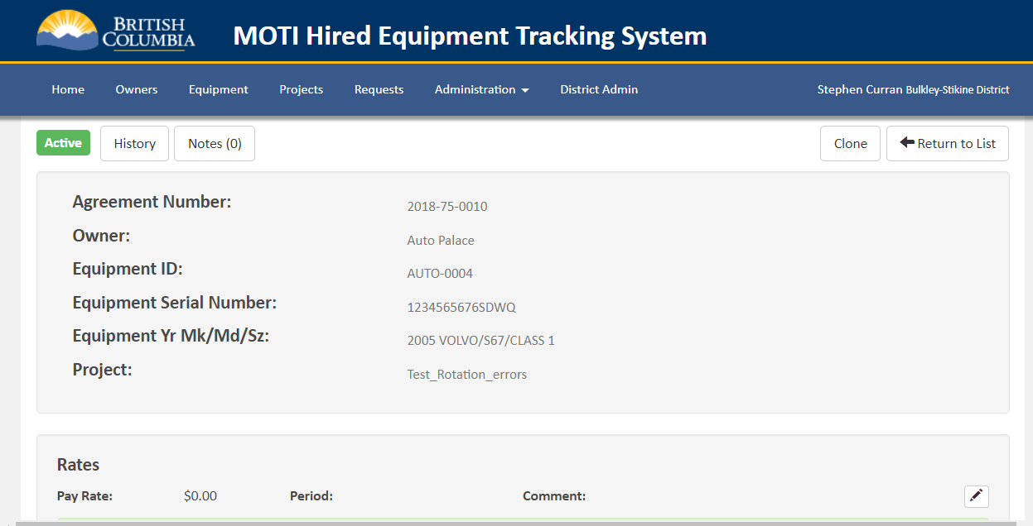

Once a piece of equipment has been selected for hire, the Rental Agreement screen is used to select the parameters to go onto the Rental Agreement page. Like other screens in the HETS app, there are some fields at the top of the screen (e.g. status, notes, return to list) and a History table at the bottom of the screen (not displayed). There is also a special "Clone" button (1) at the top that is described later.

There are four groups of information to be completed for a Rental Agreement:

* Rates - the rate for the piece of Equipment at least, and optionally for additional rates applicable to this hire.
* Attachments - the Attachments to the piece of Equipment that will also be rented for the Project
* Conditions - any rental conditions to be displayed on the Rental Agreement
* Rental Information - information about the rental.

The "Rates" section is (mostly) visible on the screenshot above. It has a row for the Rate of the piece of Equipment, with an Edit button for updating the Rate, period (Hourly or Daily) and a comment.

As well (just out of view) is a button for adding additional Rates to the Rental Agreement - for example, for adding Overtime, Rest, Standby, Labour, Swamper or some other rate. When clicked, the User can select the type of Rate, the Period (if applicable), Rate in dollars or as a percent of the Equipment Rate, and a Comment. The User may also choose to include the added Rate in the total Rate for the Rental or not. Multiple Rate types can be added as needed.

We'll cover the other groups of Rental Agreement data, the Clone short cut and printing the Rental Agreement in the next sections.

### Managing Rental Agreements - Attachments and Conditions

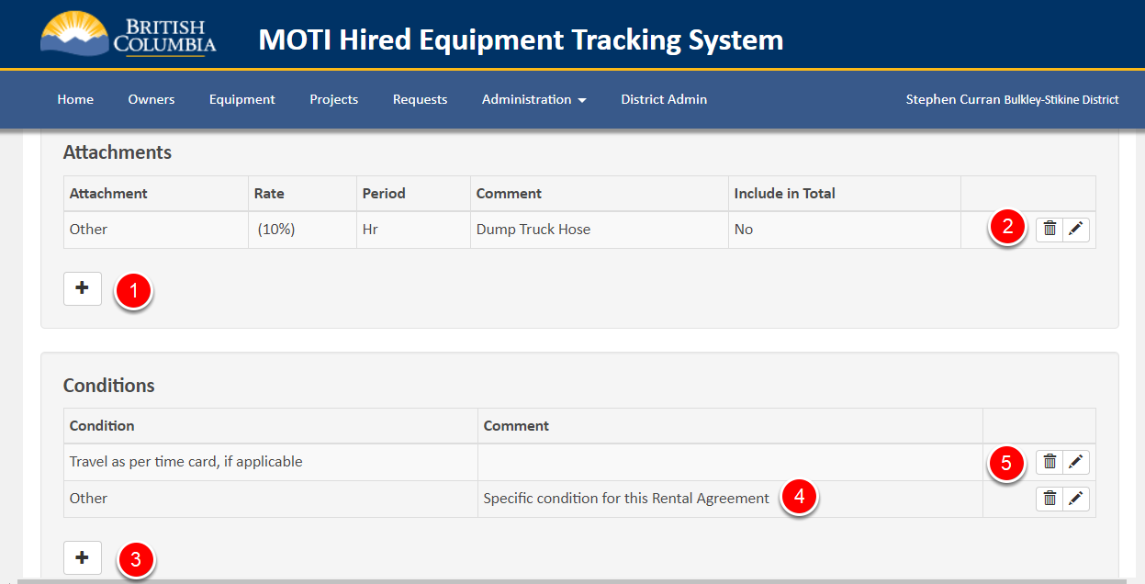

To include the Equipment Attachments in the Rental Agreement, click the "+" button (1) in the Attachments section. A popup will display allowing the User to add one or more Attachments with the following information:

* The Attachment to add from a drop down list of Attachments associated with the selected piece of Equipment or "Other" if the required attachment is not listed.
* The Rate for the attachment as a percentage of the Equipment Rental or a specified dollar amount.
* Whether the Attachment rate should be included in the Equipment Rental total.
* An optional Comment.

Once added, the Attachment can be edited or removed with the pen or trash can icons associated with the Attachment (2).

To include the Conditions in the Rental Agreement, click the "+" button (3) in the Conditions section. A popup will display allowing the User to add one or more conditions with the following information:

* The condition to add from a drop down list of standard conditions or "Other" if the needed condition is not listed.
* A comment (4) that is used as the text of the Condition on the Rental Agreement when the Condition is "Other"

Once added, Conditions can be edited or removed with the pen or trash can icons associated with the Condition (5).

It's a lot of information to be added for every Rental Agreement, so the Clone button has been added as a shortcut for getting all that information from an existing Rental Agreement.

### Managing Rental Agreements - Cloning an Existing Agreement

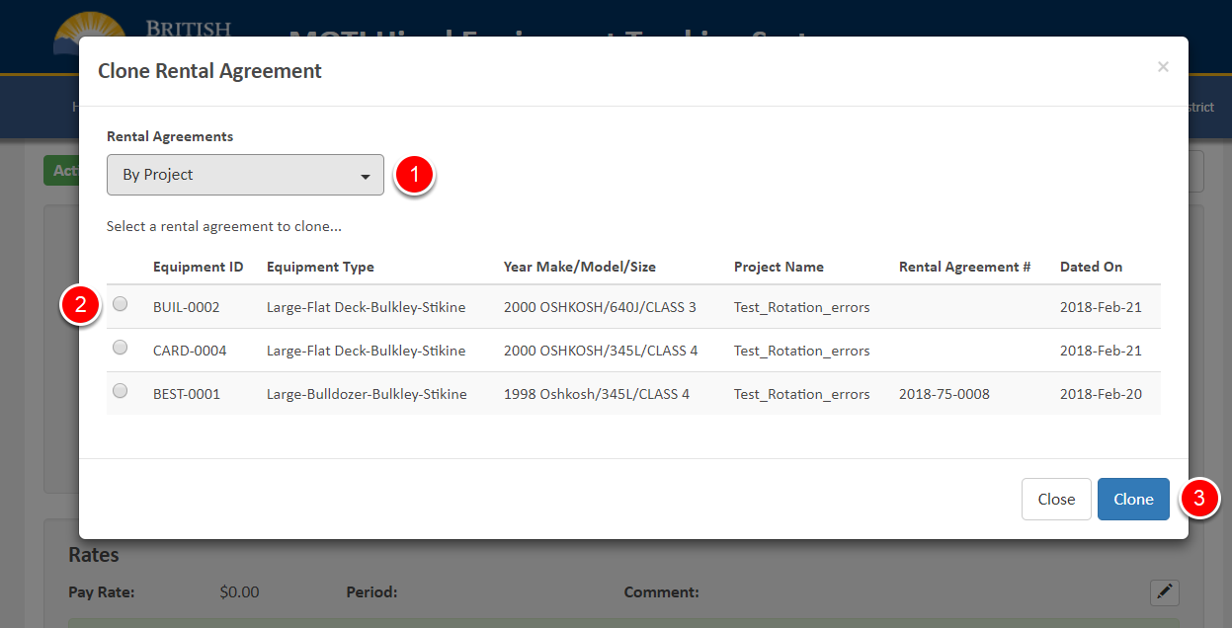

To save time in creating Rental Agreements, the Clone button (at the top of the Rental Agreement screen) can be used. When clicked, the popup above is displayed, listing the other Equipment with existing Rental Agreements on the current Project. The User may also change from using existing Rental Agreements from the current Project to using previous Rental Agreements for this piece of Equipment by changing the "By Project" option (1).

Use the radio buttons (2) to select one of the Rental Agreements and click Clone (3). The Rental Agreement will be updated to include (almost) all of the data from the existing Rental Agreement, and you can continue with generating the Rental Agreement document.

The only time some data is not copied to the cloned Rental Agreement is if you use a Rental Agreement from another piece of Equipment, and the Rental Agreement included specific Attachments associated with that piece of Equipment. Note that any "Other" attachments are carried over to the cloned Rental Agreement.

### Managing Rental Agreements - Generating a Rental Agreement

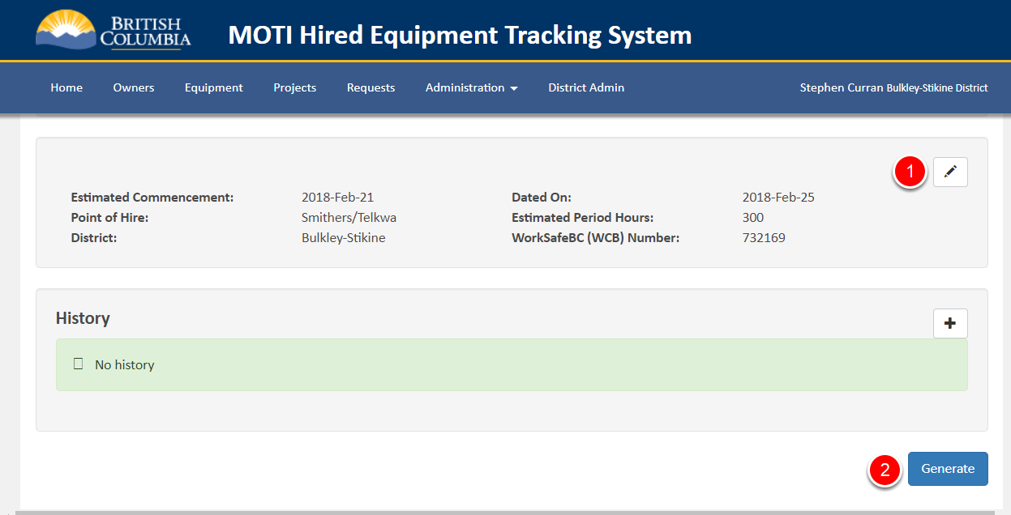

The final part of Rental Agreement data to be updated is shown in the screenshot above, with a Pen icon to allow editing of the data (1). The information in the section is mostly picked up from existing data (both the Request and the Equipment data), so although it should be verified, it may not need to be updated.

Once all of the data about the Rental Agreement is ready, click the Generate (2) button to create the Rental Agreement. When first clicked:

* A Rental Agreement number will be generated (e.g. "2018-75-0008"), and
* A PDF will be generated

**NOTE**: The PDF is generated in a popup window and your browser may prevent the popup window. If that happens, use the browser settings to always allow popups from HETS. <<Detailed steps to do this to be added>>

Once generated the first time, the piece of Equipment has been hired (at least from the HETS app perspective) and:

* The piece of Equipment has been flagged as "Hired"
* The piece of Equipment can be "Released" when the Rental Agreement work completes
* Time can be entered for the piece of Equipment against the Rental Agreement

# Tips and Tricks

This section provides some tips and tricks for effectively using the HETS application. The previous sections have covered the mechanics of using each of the screens in the system. This section is based on the tasks that HETS users need to do to complete their work and provides tips and tricks for accomplishing those tasks.

<<Topics in this section are to be defined and added>>

# Changes from BC Bid

This chapter is for HETS Users that are used to the BC Bid version of HETS. It covers some of the bigger changes that have been made in creating this new version of HETS. As mentioned in the first chapter of this User’s Manual, if you are coming to this system from BC Bid, you will find that while you can accomplish the same things that you did on the old system, the methods to do so are quite different. You will not find the same menu items and screens in this system, and even some terminology has changed. Our goal in designing and building this system was to make it easier for users to accomplish the HETS Program’s goals, and to do so online, with less paper. You can still use paper (of course!), but hopefully you will find it's just easier to not duplicate work by doing it on paper and then in the system.

### Rental Requests - Paper vs. Online

One term that is used differently in this system is "Requests" a short form of “Rental Requests”. In this system, “Rental Requests" have a definition different from the "Paper Requests" received from Projects.

A "Rental Request" is a request:

* For **One** Project
* To Hire **One or More** pieces of Equipment
* Of **One** Equipment Type
* In **One** Local Area
* Using **One** Rotation List

This is different from the "Paper Requests" received from a Project Manager for several pieces of Equipment of different Equipment Types. Such a "Paper Request" will generate multiple "Rental Requests" - one for each Equipment Type.

When a Rental Request is created in the system, a Rotation List is generated based on the current state of the Seniority List, and that Rotation List is used throughout the hiring process for the Request. This process is detailed in the "Managing Requests" section of this User’s Manual.

### Last Verification Date

One of the major changes from the BC Bid system is the approach for keeping the list of Equipment accurate. In the BC Bid system the approach was:

* In preparation for Roll Over - renew every piece of Equipment to be part of next year's program.
* Any piece of Equipment not renewed was inaccessible after Roll Over.

However, because verifying all Equipment each year is time-consuming, HETS Users often were forced to renew Equipment without verifying with the Owners before renewal.

In the new HETS, the approach to keeping the list "fresh" has been changed to tracking the "Last Verified Date" on each piece of Equipment. With this approach, Equipment remains on the list until removed (no automatic Roll Over removals) and instead, the last date the piece of Equipment was verified is tracked.

* The Date can be updated in the same way renewals were done in the old system - e.g. letters to the Owners to have them confirm their current Inventory of Equipment in the HETS program. For each confirmed piece, a button allows the user to update the "Last Verified Date" to today.
* As well, as a Request to Hire is processed, and Equipment Owners are contacted about a Rental, the Last Verified Date is updated. We think this is the most common way that the Date will be updated - a byproduct of the normal workflow.
* As well, we've added the ability for a HETS User to flag a piece of Equipment as "Needing an Update" as part of the Rental Request process. That allows a HETS User to quickly flag a piece of Equipment that needs updating (eg. has gone out of Service) as part of their work, and deal with actual update (e.g. archiving the Equipment) later.

Further, from the Equipment List screen, you can get a list of Equipment that has not been verified since a given date - e.g. Not Verified for a year. That allows a HETS User to spend what little time they have on verifying the list on the Equipment that has not been verified recently. As well, the User can get a list of all of the Equipment that have been marked as "Needing an Update" to process those updates when there is time.

We think this approach will be much more useful for keeping the HETS Equipment List fresh.